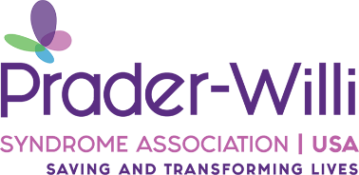[Your Name]  
[Your Address]  
[City, State, ZIP Code]   
[Your Email]  
[Your Phone Number]  
[Date]

The Honorable [Legislator’s Name]  
[Legislator’s Office Address]  
[City, State, ZIP Code]

Dear [Legislator’s Name],

I am writing to you as a resident of [Your City/Town] and a passionate advocate for individuals living with Prader-Willi syndrome (PWS), a rare and complex genetic disorder that impacts approximately one in every 15,000 births. I am urging you to support and co-sponsor SB1651, introduced by Senator Morrison, and HB2541, introduced by Representative La Ha. These crucial pieces of legislation aim to improve the lives of those with PWS and other rare disorders by ensuring better access to necessary resources, services, and care.

PWS is a lifelong condition that presents significant medical and behavioral challenges, including insatiable hunger, developmental delays, and life-threatening complications. Many individuals with PWS require specialized support, yet families frequently face barriers to accessing essential care. SB1651 and HB2541 will help remove these barriers and provide the necessary infrastructure to support individuals with PWS and their caregivers.

By supporting these bills, you are taking a stand for the rare disease community and ensuring that Illinois becomes a leader in compassionate and effective policy for those with complex medical needs. I respectfully ask that you not only support but also co-sponsor SB1651 and HB2541 to help bring meaningful change to the lives of individuals and families affected by PWS.

Please let me know if you would like to discuss this issue further. I appreciate your time and consideration and look forward to your leadership on this critical matter.

Sincerely,  
[Your Name]  
[Your Address]  
[Your Email]  
[Your Phone Number]