How to customize and download the PWS Awareness Month Social Media Profile Picture

IMPORTANT NOTE: You must already have or create a Canva account to be able to edit this profile picture graphic. You can create an account at https://www.canva.com/free/. Canva accounts are free.

Step 1: Open the link to the Canva customizable graphic (you can click here to access the link).

Step 2: You will see a photo already in place of the last person who used the link. You will not be able to delete the photo because the graphic is “locked.” You can, however, add your personal photo to the graphic.
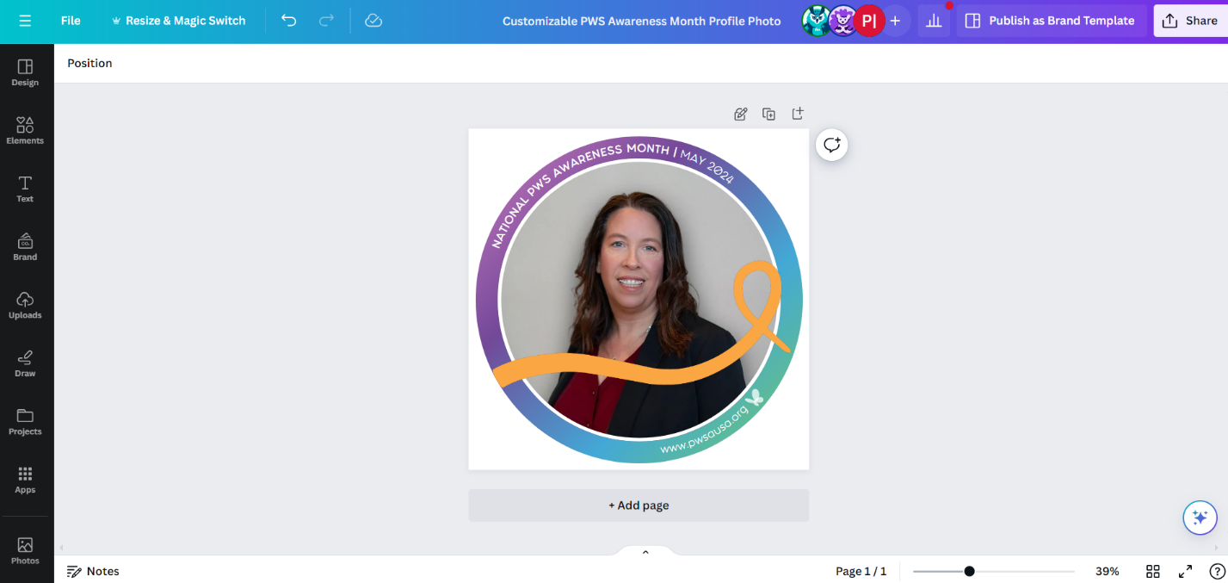

Step 3: Click the “Upload” button in the left column of the webpage, then select the purple “Upload files” button.
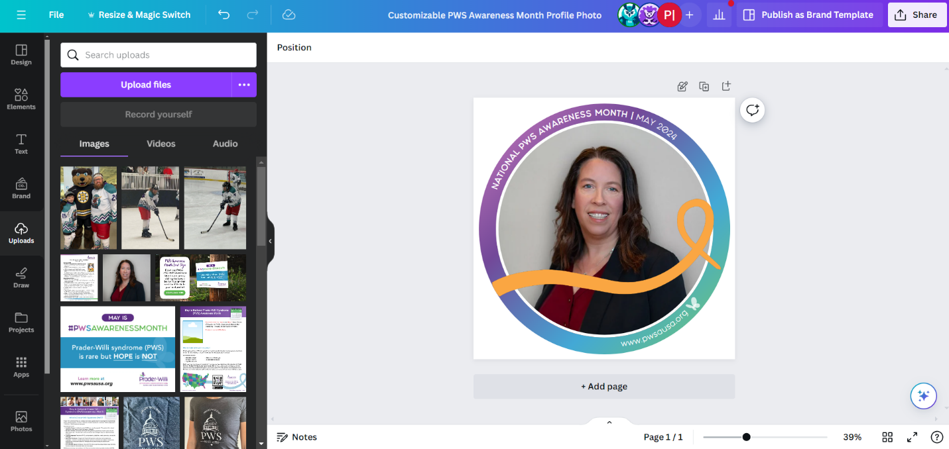

Step 4: A folder will open and prompt you to locate the photo you want to upload into Canva.

Step 5: Once the photo has been uploaded, you will see if populate in the “Images” gallery.
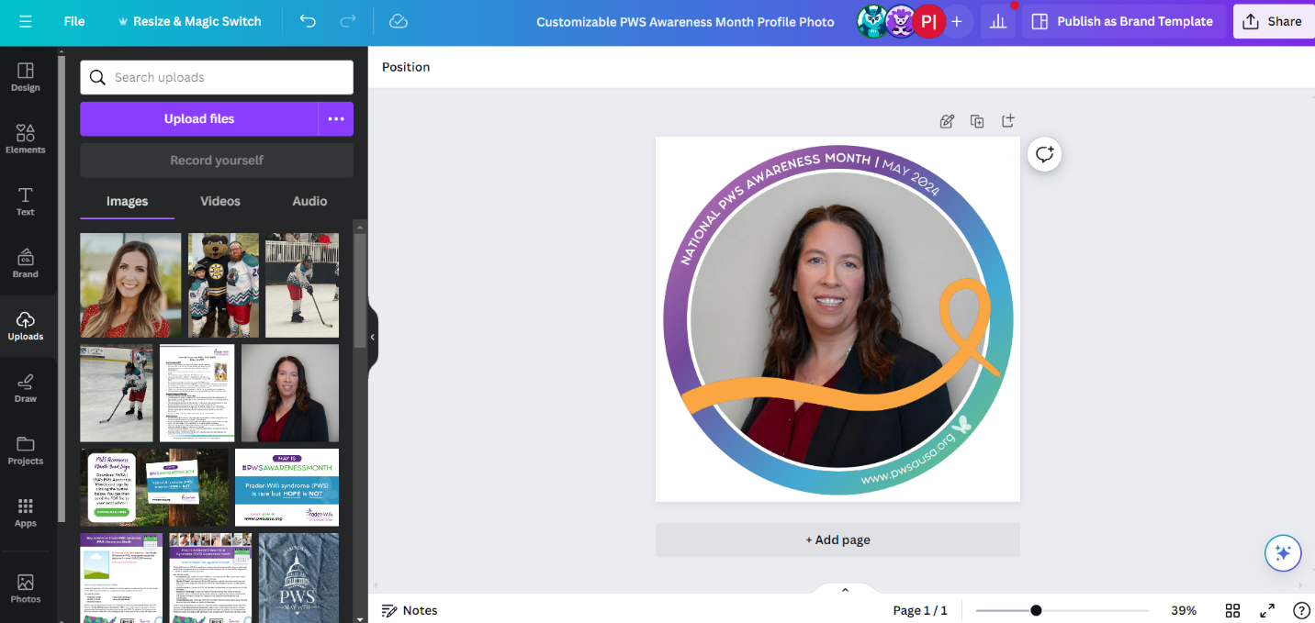
Step 6: Click on the newly uploaded photo and continue to keep it selected as you drag it into the design. Wait until you see it “lock” into the circle shape and cover up the old photo before letting go of your mouse. See how this is done below.
Step 7: Once your photo has been added to the graphic, select the “Share” button in the top right corner of the screen.
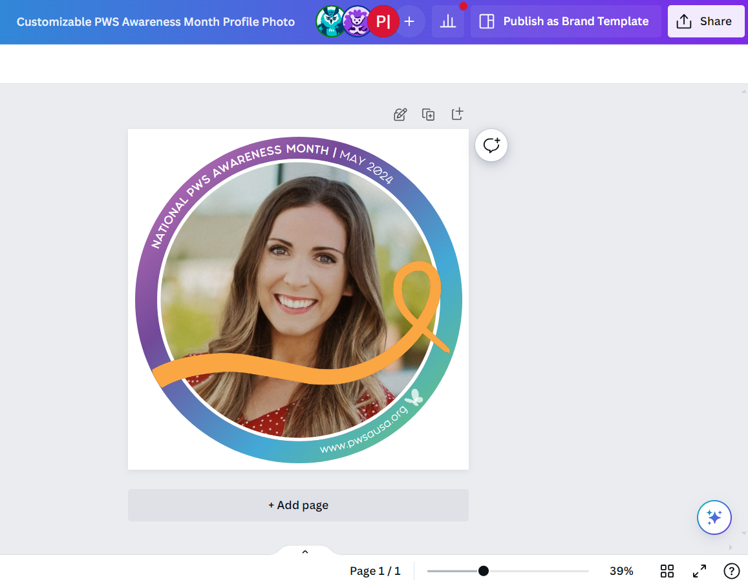
Step 8: You will see a few options pop up on the screen. Select the “Download” button.
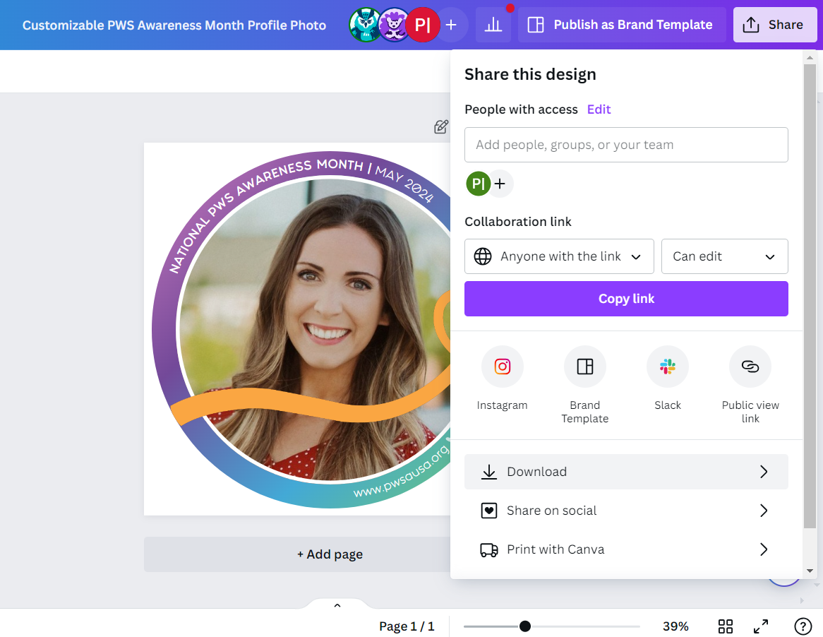
Step 9: You will be prompted to click “download” again. Click “download” and the graphic will be saved to your computer’s downloads folder. Open the downloads folder on your computer to access the graphic and upload it as your social media profile picture!
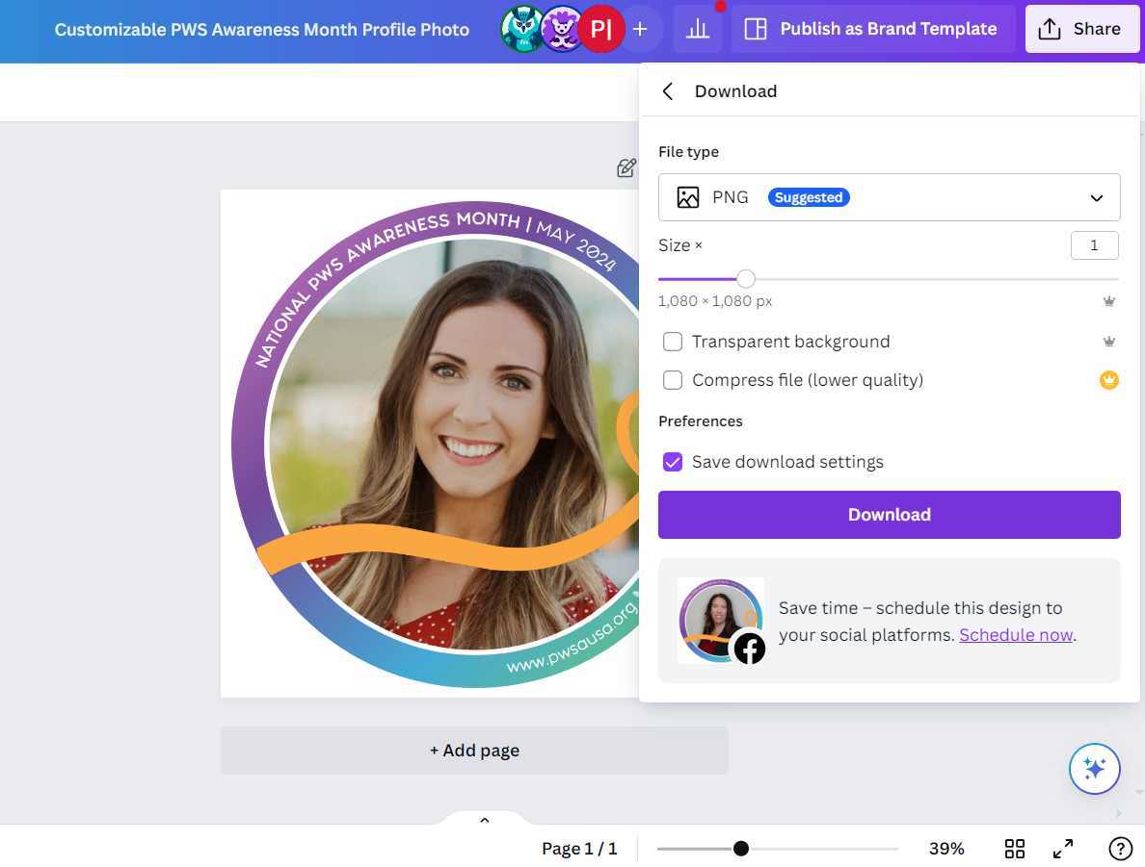

Enjoy and thank you for raising awareness for
Prader-Willi syndrome!

